TOKYO JAPAN WEATHER DATA

|  |  |  |  |  |  |  |
| --- | --- | --- | --- | --- | --- | --- |
|  | Apr-16 | SORT | Jun-16 | SORT | Jan-16 | SORT |
|  |  |  |  |  |  |  |
| 1 | 60 | 53 | 77 | 69 | 53 | 42 |
| 2 | 55 | 55 | 77 | 69 | 53 | 44 |
| 3 | 62 | 57 | 73 | 71 | 55 | 44 |
| 4 | 71 | 60 | 77 | 71 | 55 | 46 |
| 5 | 53 | 60 | 69 | 73 | 57 | 46 |
| 6 | 66 | 60 | 73 | 73 | 51 | 46 |
| 7 | 69 | 62 | 69 | 73 | 55 | 48 |
| 8 | 68 | 62 | 77 | 73 | 51 | 48 |
| 9 | 71 | 66 | 73 | 75 | 50 | 48 |
| 10 | 69 | 66 | 80 | 75 | 55 | 48 |
| 11 | 60 | 66 | 82 | 75 | 50 | 48 |
| 12 | 57 | 66 | 80 | 77 | 46 | 50 |
| 13 | 66 | 66 | 71 | 77 | 48 | 50 |
| 14 | 62 | 66 | 77 | 77 | 50 | 50 |
| 15 | 66 | 66 | 71 | 77 | 50 | 50 |
| 16 | 66 | 68 | 75 | 77 | 50 | 50 |
| 17 | 71 | 68 | 82 | 77 | 48 | 50 |
| 18 | 75 | 68 | 87 | 77 | 50 | 50 |
| 19 | 69 | 68 | 82 | 78 | 50 | 50 |
| 20 | 66 | 69 | 80 | 80 | 50 | 50 |
| 21 | 69 | 69 | 77 | 80 | 48 | 51 |
| 22 | 66 | 69 | 75 | 80 | 50 | 51 |
| 23 | 69 | 69 | 80 | 80 | 44 | 53 |
| 24 | 66 | 69 | 77 | 80 | 46 | 53 |
| 25 | 69 | 69 | 84 | 82 | 44 | 53 |
| 26 | 75 | 71 | 82 | 82 | 46 | 53 |
| 27 | 68 | 71 | 80 | 82 | 53 | 55 |
| 28 | 60 | 71 | 73 | 82 | 53 | 55 |
| 29 | 68 | 75 | 75 | 84 | 48 | 55 |
| 30 | 68 | 75 | 78 | 87 | 42 | 55 |
| 31 |  |  |  |  | 48 | 57 |
|  |  |  |  |  |  |  |
| SUM= | 1980 |  | 2313 |  | 1549 |  |
| SUMSQ= | 131498 |  | 178903 |  | 77791 |  |
|  |  |  |  |  |  |  |
| MIN |  | 53 |  | 69 |  | 42 |
| MAX |  | 75 |  | 87 |  | 57 |
|  |  |  |  |  |  |  |

SAMPLE MEAN $\overline{x}=\frac{\sum{x}}{n}$

SAMPLE MEDIAN $\tilde{x}$ $=\left\{\begin{aligned}middle value of sorted data when sample size is odd \\ average of two middle values of sorted data when sample size is even\end{aligned}\right.$

SAMPLE VARIANCE $s^{2}= \frac{n\left(\sum{x^{2}}\right)- {(\sum{x)}}^{2}}{n(n-1)}$

SAMPLE STANDARD DEVIATION $s=\sqrt{s^{2} }≥0$

METHOD 1: Calculate $\overline{ x}$, $\tilde{x}$, $s^{2}$, $s$, and QUARTILES $Q_{1,}Q_{3}$.

|  |  |  |  |
| --- | --- | --- | --- |
|  | Var-1 (Apr-16) | Var-2 (Jun-16) | Var-3 (Jan-16) |
| $$sample size n$$ | 30 | 30 | 31 |
| $$\sum{x}$$ | 1980 | 2313 | 1549 |
| $$\sum{x^{2}}$$ | 131,498 | 178,903 | 77,791 |
| $$\overline{x}$$ | 1980/30 = 66 | 2313/30 = 77.1 | 1549/31 $≅$ 50 |
| $$\tilde{x}$$ | (66+68)/2 = 67 | (77 + 77)/2 = 77 | 50 |
| $$s^{2}$$ | $$\frac{30\left(131,498\right)-{(1980)}^{2}}{30(29)}≅28.207$$ | $$\frac{30\left(178,903\right)-{(2313)}^{2}}{30(29)}≅19.679$$ | $$\frac{31\left(77,791\right)-{(1549)}^{2}}{31(30)}≅13.0323$$ |
| $$s$$ | $$\sqrt{28.207}≅ 5.311$$ | $$\sqrt{19.679}≅ 4.436$$ | $$\sqrt{13.0323}≅3.610$$ |

QUARTILES $Q_{1,}Q_{3}$

The first quartile is defined as the value with 25% or less of the data less than $Q_{1}$ when the data is sorted. The third quartile is defined as the value with 75% or less of the data less than $Q_{3}$ when the data is sorted.

1. For Var-1, 30/4 = 7.5, so the 8th value in the sorted data is $Q_{1}$ = 62, and (3/4)30 = 22.5, so the 23rd value in the sorted data is $Q_{3}$ = 69.
2. For Var-2, the 8th value in the sorted data is $Q_{1}$ = 73, and the 23rd value in the sorted data is $Q_{3}$ = 80.
3. For Var-3, the 8th value in the sorted data is $Q_{1}$ = 48, and the 24th value in the sorted data is $Q_{3}$ = 53.

|  |  |  |
| --- | --- | --- |
| Var-1 | Var-2 | Var-3 |
| $Q_{1}$ = 62 | $Q_{1}$ = 73 | $Q_{1}$ = 48 |
| $Q_{3}$ = 69 | $Q_{3}$ = 80 | $Q_{3}$ = 53 |

METHOD 2: STATISTICAL CALCULATOR (Pictured: TI-30XS, $20) 

Shown below are the instructions to enter the data. The data are 30 values listed in Apr-16. The first photo shows the keystrokes to enter the 30 data values. The second photo shows the data screen showing the first value in the data set. The calculator denotes this value on the bottom line as L1(1) = 60. The third photo shows the result of scrolling down the list to the last value entered L1(30) = 68. The scroll button is shown in the third photo as the large black button.

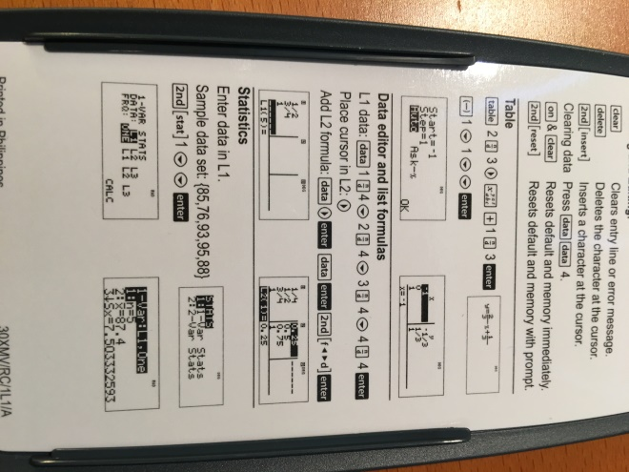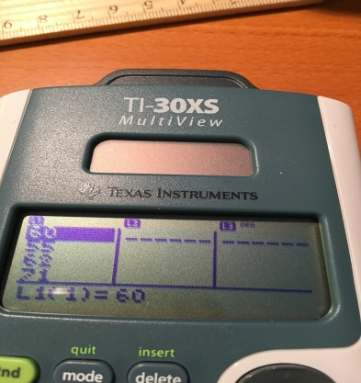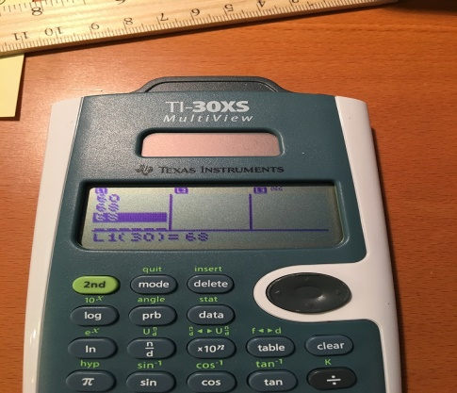

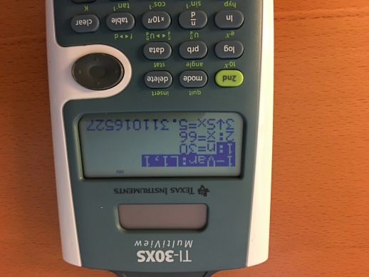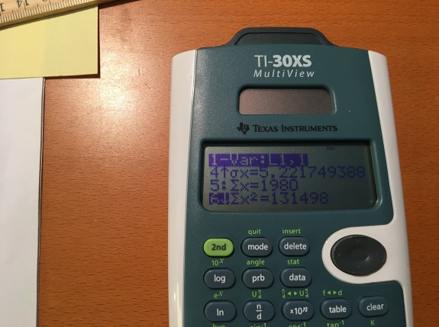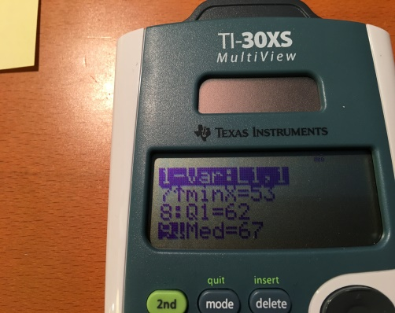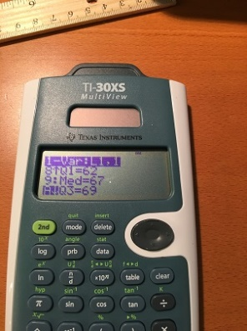

The four photos above show the result of highlighting CALC and pressing enter on the calculator. After pressing enter, you will see the screen in the leftmost photo: 1: n = 30, 2: $\overline{x }$ = 66, 3: Sx = 5.311016527. Use the scroll button to scroll down to obtain 5: $\sum{x}$ = 1980, 6: $\sum{x^{2}}$ = 131498. Continue scrolling to see 7: minX = 53, 8: Q1 = 62, 9: Median = 67, and 10: Q3 = 69.

METHOD 3: STATCRUNCH. Enter the data into StatCrunch by: 1. Copying and pasting the data from your spreadsheet into StatCrunch, or by 2. Loading the file right into StatCrunch, or by 3. Manually entering the data right into StatCrunch. From there, you can compute Summary Statistics (as shown below)

**Summary statistics:**

| **Column** | **n** | **Mean** | **Variance** | **Std. dev.** | **Std. err.** | **Median** | **Range** | **Min** | **Max** | **Q1** | **Q3** |
| --- | --- | --- | --- | --- | --- | --- | --- | --- | --- | --- | --- |
| Apr-16 | 30 | 66 | 28.206897 | 5.3110165 | 0.96965452 | 67 | 22 | 53 | 75 | 62 | 69 |
| Jun-16 | 30 | 77.1 | 19.67931 | 4.4361369 | 0.80992408 | 77 | 18 | 69 | 87 | 73 | 80 |
| Jan-16 | 31 | 49.967742 | 13.032258 | 3.6100219 | 0.64837907 | 50 | 15 | 42 | 57 | 48 | 53 |

BOXPLOTS, HISTOGRAMS, and SCATTERPLOTS were generated by StatCrunch using the Graph command.

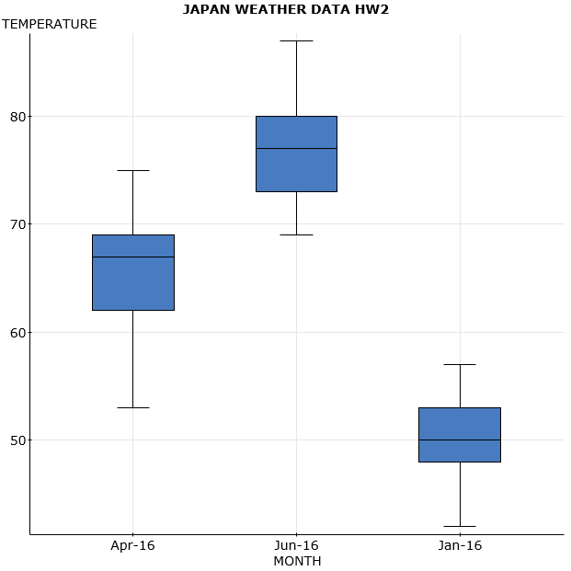

HISTOGRAMS:

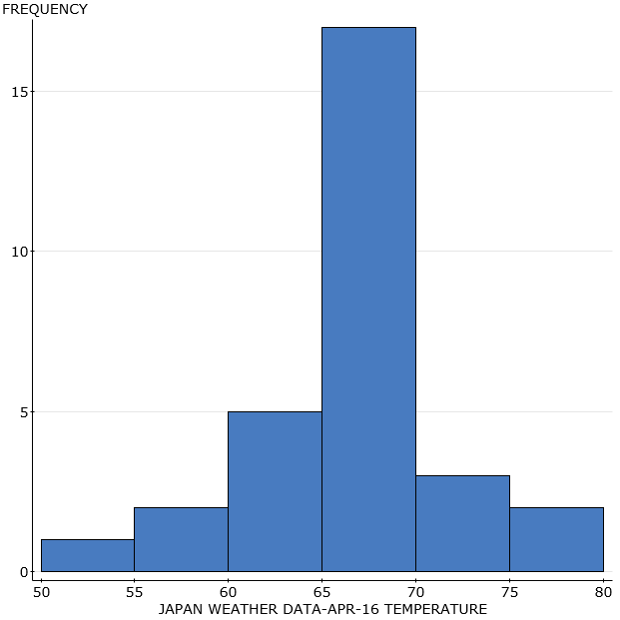

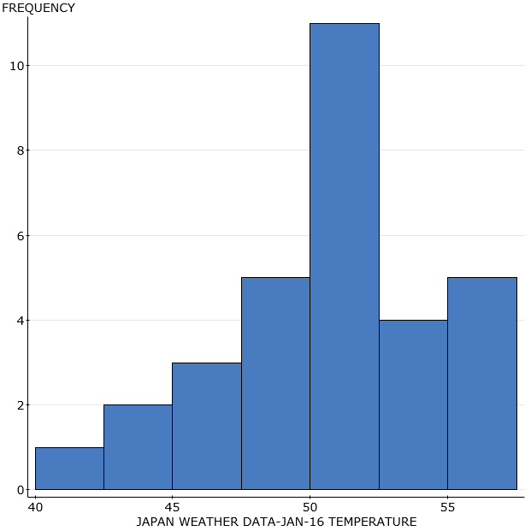

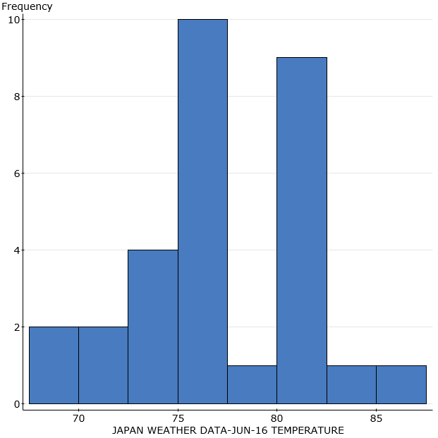

SCATTERPLOTS: JUN-16 X APR-16, JAN-16 X APR-16, JAN-16 X JUN-16